## PROJECT REPORT ON

**University Login System**

**Java Swing technology**

Submitted By:

Shad ahmed.

**23 April, 2016**

**CONTENTS**

|  |  |
| --- | --- |
| **No.** | **Topics** |
| 1. | Introduction |
| 2. | Project description |
| 3. | Technology overview |
| 4. | Snapshots |
| 7. | Scope of project |
| 8. | Future Plan |

1. **INTRODUCTON**

University Login System can be used by education institutes to maintain the records of students easily. Achieving this objective is difficult using a manual system as the information is scattered, can be redundant and collecting relevant information may be very time consuming. All these problems are solved using this project.

1. **Objectives**

* Publish Result of students
* Maintenance of student records
* Searching student records
* Insert,Upadte or delete student records

**3. Project description**

There are two different users who will be using this product:

* Administrator who can view and edit the details of any students.
* Students who can view their details and edit some of their details .

The features that are available to the Administrator are:

An Administrator can login into the system and perform any of the available operations.

* delete student detail.
* edit student information from the database.
* make search for a specific student.
* access all the details of the student.
* upload image.

The features that are available to the student are:

Student can login into the system and can perform any of the available options

* view personal details.
* edit password
* view Result.
* upload image

**Operating Environment :**

* The product can run on any browser under server .

**Constraints :**

* Every user must be comfortable using computer.
* All operations are in English so user must have basic knowledge of English.

**4.TECHNOLOGY OVERVIEW**.

**MySQL** : MySQL is a relational database management system (RDBMS) that runs as a server providing multi-user access to a number of databases. MySQL is a popular choice of database for use in open source product. The process of setting up a MySQL database varies from host to host.

**JAVA:** swing is a GUI widget toolkit for Java. It is part of Oracle's Java Foundation Classes (JFC) – an API for providing a graphical user interface (GUI) for Java Swing provides a native look and feel that emulates the look and feel of several platforms, and also supports a pluggable look and feel that allows applications to have a look and feel unrelated to the underlying platform

**5. SNAPSHOTS ADMIN LOGIN PART**

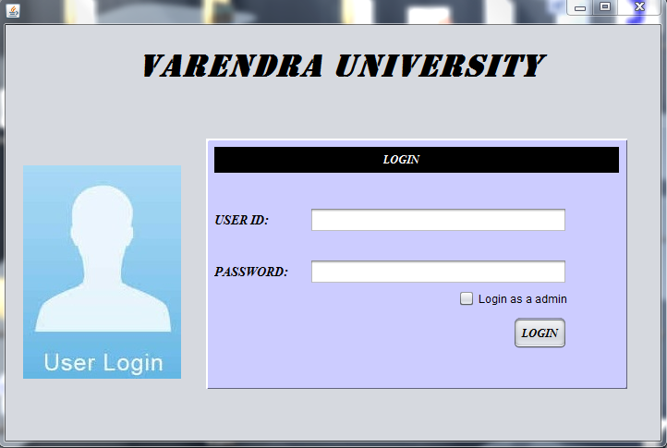

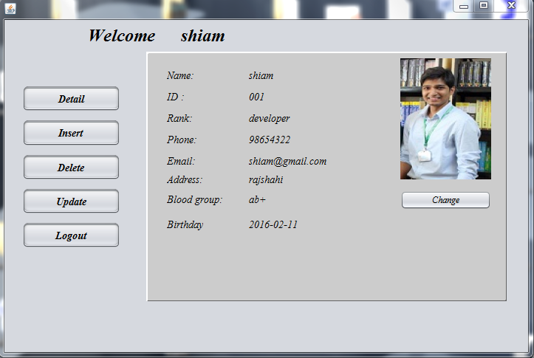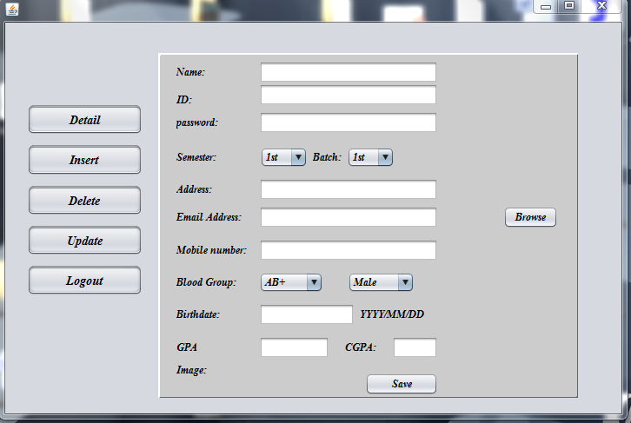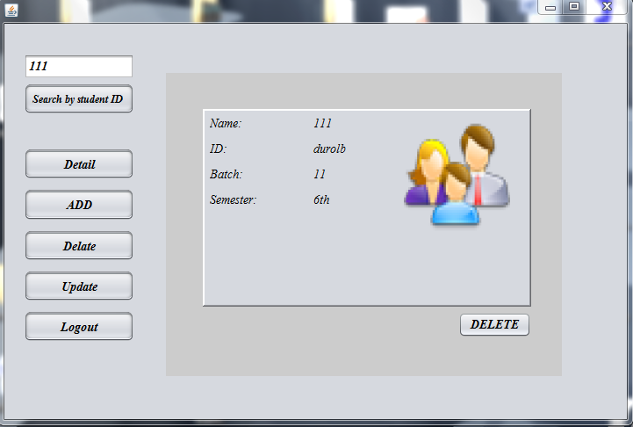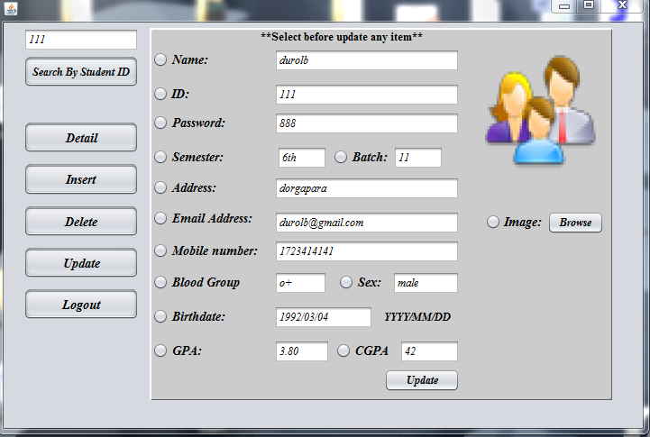

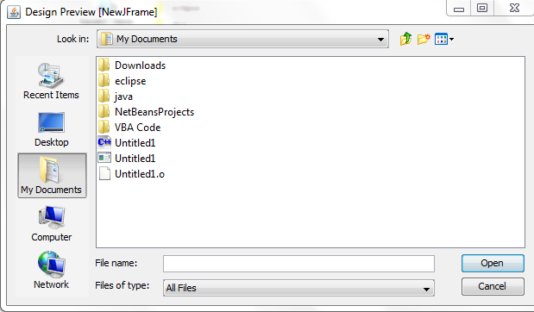

**SNAPSHOTS STUDENT LOGIN PART**

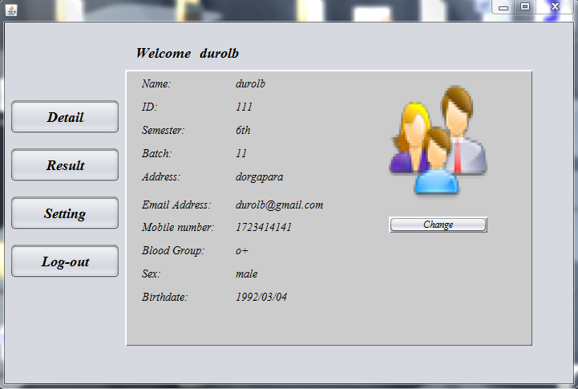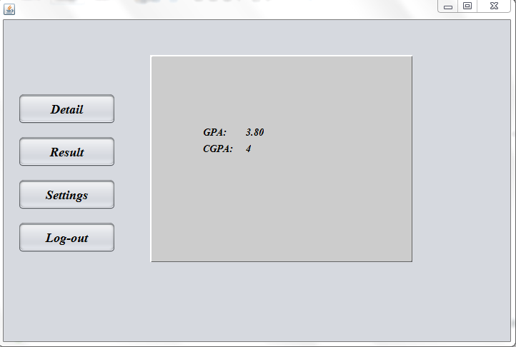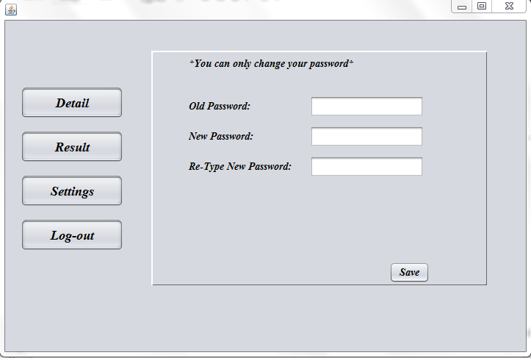

**SNAPSHOTS OF DATABASE TABLE**

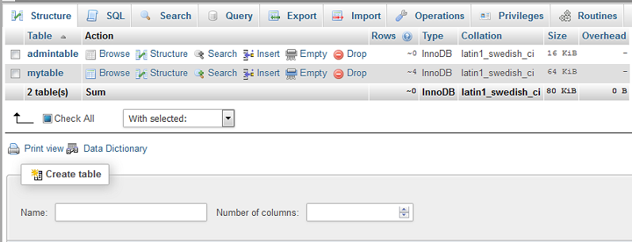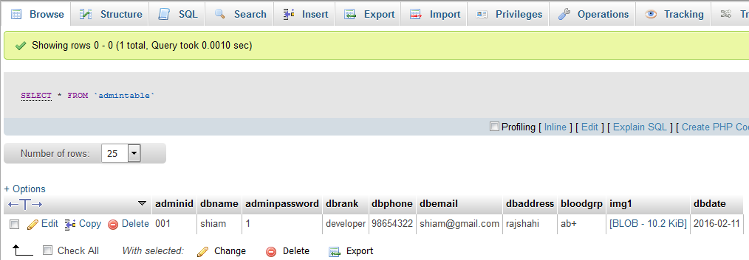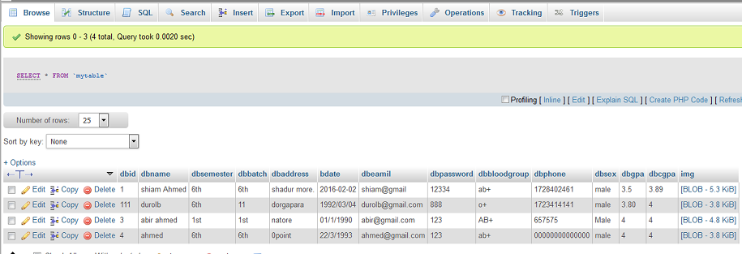

**6. SCOPE OF THE PROJECT**

* University
* Collage
* Educational Institute

**7.Future Plan**

* The University Login System can be enhanced to include some other functionality like marks, attendance ,payment detail .
* Social networking can also be added where students can interact with each other.
* Functionality of chat and messages can be added.